Overview
The Open EUA Consortium (OEC) is a recently formed group of COVID test developers who are cooperating to create low-cost, widely available, FDA validated tests.

Following in the footsteps of SalivaDirect (Wyllie, Grubaugh), the primary mode of the OEC is to provide labs with "open source" protocols. To run an Open EUA test, labs can either be officially "designated" to operate under the EUA and according to the IFU, or CLIA labs can re-validate the test as their own LDT. Further, non-CLIA labs can also run the tests (using sample pooling) under the "surveillance" regime, with the confidence that the baseline protocol is validated and well characterized.

The plan is to obtain 5-8 core Open EUAs that include various sample types and technologies, This suite of Open EUAs will cover the majority of lab testing needs, from small to medium sized labs, and the most common equipment sets. Importantly, the suite will also cover individual clinical diagnostic testing of people with symptoms or persons suspected of COVID as well as large scale pooled screening of schools and workplaces.

An key aspect of the OEC is that ultimately the EUAs belong to and are controlled by entities. Normally the interactions between these entities, which are usually companies, and the FDA are totally siloed and considered trade secret. We're breaking down those barriers and cooperating by sharing knowledge of the FDA process and expectations, and perhaps sharing key validation materials such as characterized controls and clinical samples. We are seeking priority with the FDA for expedited review and open channels of communication.

In addition to identifying the suite of assays, validation/bridging studies, and other regulatory work, parallel efforts need to quickly be spun up to 1) secure the supply chain of chemicals and consumables, 2) organize the logistics at the national, state, and local levels, and 3) build out the implementation playbooks for the major stakeholders, such as governors, mayor, DPHs, labs, screening programs, schools, businesses, and individuals.

This plan is ambitious, but all the pieces are in place to execute today.

Mission
Our mission is to usher in a new era of open source molecular testing to improve human health.

Goals
Overarching goal is to expand COVID testing as quickly as possible in the U.S. to have positive impact on the crisis and help save lives.

More specifically, goals include:
- Obtain FDA authorizations for a suite of Open EUAs covering a variety of testing needs [by end of Dec]
- Establish prioritization at the FDA for Open EUAs and a structure for expedited communication [by mid Dec]
- Gather support and funding, both for the individual entities pursuing Open EUAs and for the consortium collectively (with dedicated or dotted line staff).
- Establish a framework for Open EUAs, addressing legal, business, and practical issues.
- Cooperate with a greater effort and the National Testing Plan to put the supply chain, logistics, and playbooks in place to quickly maximize the potential of the suite of Open EUAs [throughout Dec on, plan in place by end of Dec]

Who
The OEC is currently composed of 5 groups and will soon be recruiting more.
See groups and summary of their tests and status below.
Can expand to add more groups but should avoid redundancy, suggest merging similar EUAs, no publication of submitted EUAs, academic groups especially may be interested in merging
Want to avoid organization problems from adding too many groups to OEC before ready.
Guiding view is that we don't need 20 open source tests or even 10, but say 4-6.
Can add on to approved EUAs w bridging studies.
Is it possible to give a ROR to all or a big chunk of an authorized EUA for a new EUA instead of bridging onto the 1st one? If so, provides a streamlined way to expand without draining resources of authorized EUA holder and also not jeopardizing shutdown if performance problems from labs running the 2nd EUA. Authorized EUA holder looses some control over their EUA because the new EUA holder technically has autonomy (I think unless I'm misunderstand, or some other legal arrangements are made).

OEC Chart (redacted)

Status of Consortium
Convened 1st meeting end of Nov
Next group meeting Dec 11 or 14
Soliciting funding and support
Focus this week (12/7) on LAMP primers and swabs

Current Resources
Minimal budgets and staff of each group

Needed Resources
Significant
Funding for each group individually
Joint staff either dedicated to consortium as whole to staff at one or more groups can have % allocation to consortium wide activities
Priorities for shared, consortium wide technical resources include:
- bank of positive clinical samples (pref w Ct values)
- verification panel materials (quantified spike stocks for LOD studies)
- selection of primary swabs for validation
- primers
Supply chain and logistical expertise
Contract manufacturing support
Primer production (Eurofins and LGC)
Infrastructure and local support for running pilots, particularly for pooled screening pilot projects

Designation Process
Labs, once "designated" by the EUA holder, can obtain the required chemicals and reagents and perform the protocol as described in the EUA Instructions for Use (IFU).

Rights of Reference
CDC PCR assay, primer set, extraction kits, CDC recently added pooling
Need a blanket ROR to a LAMP primer set - which one?
Gates Foundation funded the Quantigen study which has blanket ROR
What other chunks can OEC validate and offer ROR's for?

Sources of Validation Materials
Interfering substances price list with Vendor and Catalog Numbers from Pro-Lab Dx EUA

LAMP Primers
Primers Compilation LAMP
12-15 RT requesting validation run of AS1e, E1, N2 from Eurofins - 10X in water, std desalt

FDA Links

CLIA Classification

FDA Town Halls - FDA link and FloodLAMP youtube page link, our notes link
FDA Town Hall Survey

FDA Pre-EUA
CDRH-EUA-Templates@fda.hhs.gov
https://www.cms.gov/files/document/clia-university-lab-testing.pdf
https://www.fda.gov/medical-devices/coronavirus-covid-19-and-medical-devices/pooled-sample-testing-and-screening-testing-covid-19

11-17 COVID-19 Update: FDA’s Ongoing Commitment to Transparency for COVID-19 EUAs

Helpful Links
Gates Nasal Swab Presentation 9-17-20
KAREN A HEICHMAN, PhD Senior Program Officer, Innovative Technology Solutions Program Global Health at Bill and Melinda Gates Foundation
Has dry swab elution protocol (10min, vortex)

FDA SARS-CoV-2 Reference Panel Comparative Data - Google Sheet by Matt McFarlane

https://www.resiliencehealth.com/tests.html
https://opencovidpledge.org/
Pledging intellectual property for COVID-19 - Nature Biotechniques 10-5-2020

https://www.invetechgroup.com/insights/2020/05/emergency-use-authorization-how-diagnostic-developers-can-address-covid-19/

Article Links
Open-source toolkit helps developing countries meet demand for COVID-19 R&D

Suggestions for New Open Source EUA FDA Meetings
- 2-3 times per week meetings (is that necessary?)
- prefer on demand answers to questions - we can vet the questions through our group first
- define clear criteria for Open EUA
  - could ask FDA to solicit all current pre-EUAs and EUAs if they would join
- SD model
  - multiple reagent suppliers
  - don't sell kits
  - non commercial/non profit designation process
  - seems like primary mode for universities
- FloodLAMP model, Public Benefit Corp
  - EUA includes base chemicals and protocol for solution prep
  - no/low cost designation process
  - sell kits
  - partner w NEB for MM

- commonality is commitment to royalty/profit free designation to non-profit (university) labs, what about DPH and commercial? standardize on low% royalty rate - there are terms and structure to figure out here, goal is to keep it simple
- maybe the important things are open protocol and transparent, standardized terms and agreements (like SD)

LAMP EUAs
from Matt McFarlane (twitter @mattmcfar)
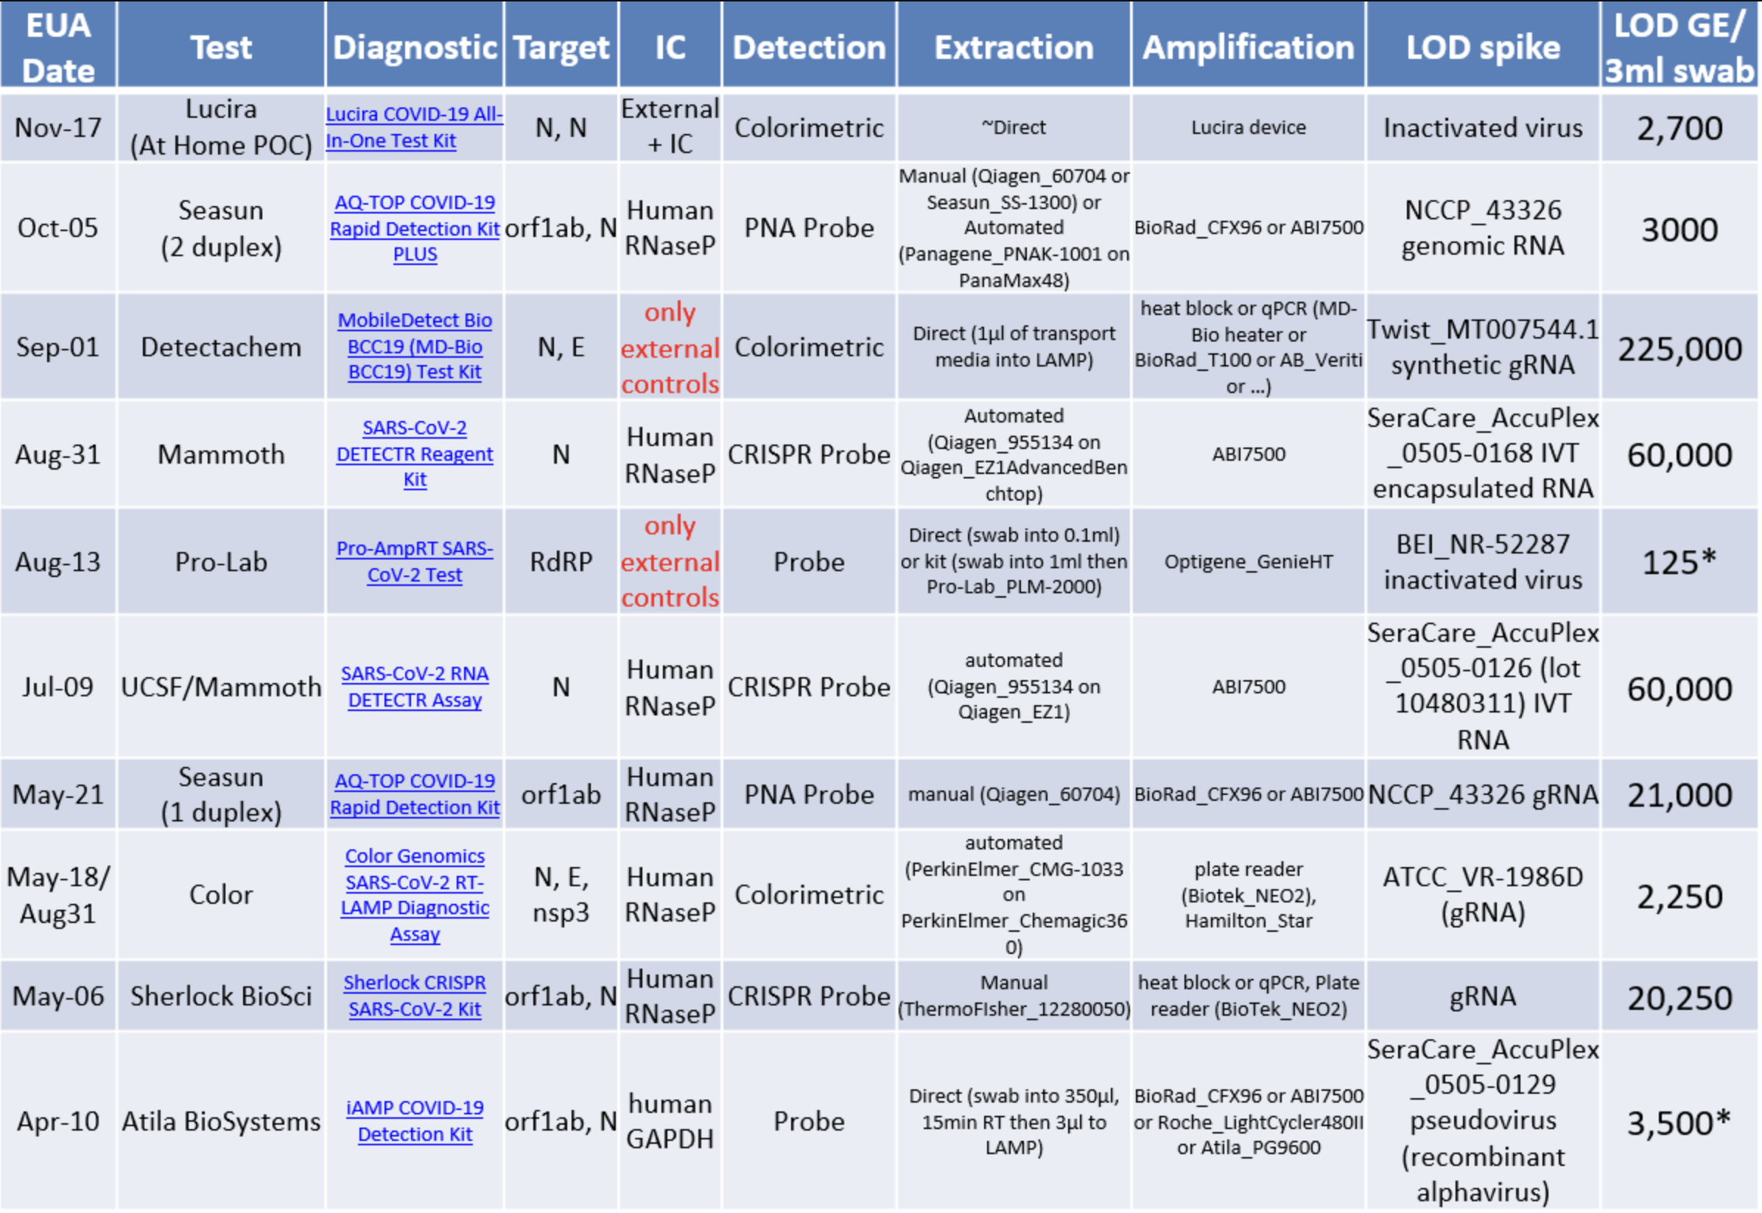

FDA Statements and Quotes
9-23 FDA Town Hall, Time Stenzel:
"the third thing was visually-read tests. So we haven’t authorized, I mean, we’ve probably authorized just one visually-read test [think this is DetectaChem]. There is a lot I know in development and hopefully they will come to the market in the relatively near future and there’s nothing wrong with the visually-read tests"
"we’re very eager to authorize home diagnostic tests either over-the-counter or by prescription. I have to say though we haven’t received a single EUA application for a home test, not one and we’ve had our template out there for a long time and we’ve clearly expressed flexibility so we want to reiterate. We want to see home test submissions and we’re willing to be very flexible here."
"So what we have attempted to do is provide as much flexibility to add an asymptomatic claim to anybody who wants one."

